1. **Create a New Partition with ext3 Filesystem  
     
   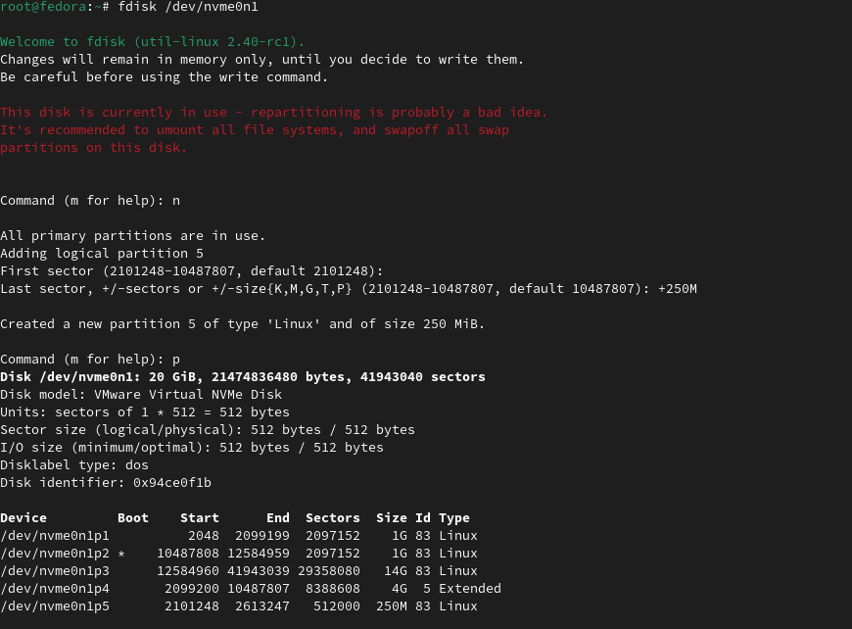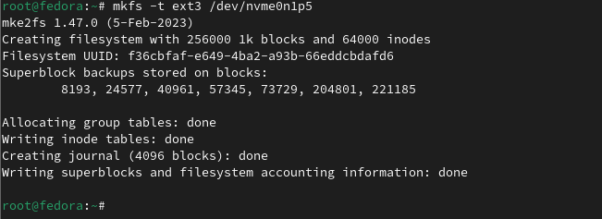**

**2.Mount the Partition to /mnt/mypartition**

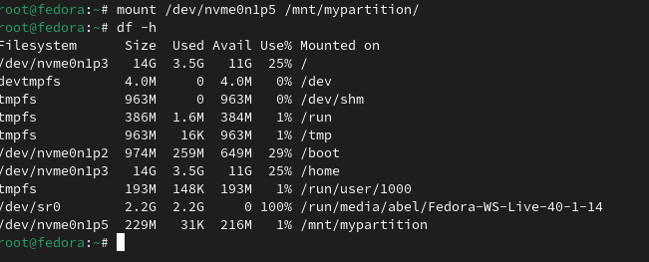

**3.Create a File with a Fake Address**

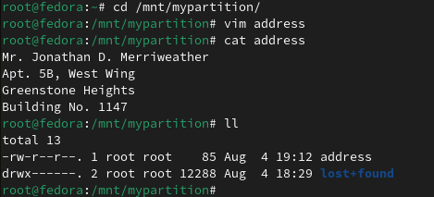

**4. Ensure Persistence After Reboot**

